MANUAL HANDLING GUIDE

**Contents Page**

Introduction 2

Injuries Associated with Manual Handling Activities 3

An Explanation of the Basic Principles of a Manual Handling Assessment 3

Ways of Reducing the Risk of Injury 4

Guideline Maximum Handling Loads 5

Manual Handling Techniques Guide 6

Manual Handling Assessment Checklist 7

# Introduction

***What Is Manual Handling?***

Most people do not understand the definition of Manual Handling, in that it is any action carried out by hand or using bodily force (movement of a load by human effort alone).

The Manual Handling Operations Regulations place a statutory duty on the employer to carry out risk assessments for all Manual Handling operations. Risk assessments should examine the various components involved, for example, the person's age, ability, sex, the type of load, weight of load, route to be taken, area to be taken to etc.

Most tasks require some form of Manual Handling however, it must be remembered that only significant risks require assessment.

Manual Handling is the most common cause of reportable accidents at work. It is often dismissed as a personal strength matter because the person is seen as being weak.

It is strongly advised that all operations should be checked to ensure there are no hidden risks e.g. repetitive strain injuries.

Training alone will not reduce manual handling injuries, there needs to be a safe system of work in place and full implementation of the control measures identified in a Manual Handling assessment.

**This Manual Handling Guide will provide you with:**

* Information regarding the injuries associated with Manual Handling
* An explanation of the basic principles of a manual handling assessment
* Ways of reducing the risk of injury

**Also included:**

* Guidelines for maximum handling loads
* Manual Handling techniques guide
* A Manual Handling assessment checklist

# Injuries Associated with Manual Handling Activities

Incorrect Manual Handling operations can cause a wide range of acute and chronic injuries to workers. It causes work-related musculoskeletal disorders (MSDs) which account for a third of all work related injuries.

The most common of these injuries are:

* Muscular pains and strains
* Back injuries
* Trapped nerves
* Hernia
* Cuts, bruising and abrasions
* Fractures
* Work related upper limb disorders
* Rheumatism

# An Explanation of the Basic Principles of a Manual Handling Assessment

The Manual Handling Operation Regulations specify four main factors which must be taken into account during an assessment, these are:

1. The Task
2. Individual Capability (capability of the individual who is expected to perform the task)
3. The Load
4. The Working Environment

# The Task

The task should be analysed in detail ensuring all aspects are covered including any mechanical assistance.

Consider:

* Is the load carried over excessive distances?
* Is there excessive pulling or pushing of the load?
* Is bending, twisting or stooping required to do the task?
* Is prolonged physical effort required?
* Is there a risk of the load suddenly moving or becoming off balance
* Are there sufficient rest breaks or recovery periods?
* Does the load require the involvement of two or more people?
* Is a satisfactory body posture being adopted?

# The Load

Consider the load as part of the assessment and consider:

* Is the load too heavy?
* Is the load bulky or unwieldy?
* Is the load difficult to grasp?
* Are the contents likely to shift or become off balance?
* Is the load sharp, hot or cold?

# The Working Environment

* Are there space constraints preventing good posture? (uneven, slippery or unstable floors)
* Variation in work surface levels (steps, slopes, benches)
* High or low temperatures
* High humidity
* Poor ventilation
* Strong winds, gusts or other air movements
* Lighting
* Moving workplace i.e. boat or train

# Individual Capacity

Does the activity require any unusual characteristics of the individual (strength or height)?

Problems with clothing?

Vulnerable groups e.g. pregnancy, new and expectant mothers, young workers or lone workers Does the individual have any injuries or health problems, back problems or hernia?

The regulations require employees to:

* Avoid the need, as far as is reasonably practicable, for hazardous Manual Handling
* If it cannot be avoided, to assess the risk of injury arising from hazardous Manual Handling
* Reduce the risk of injury as far is as reasonably practicable arising from hazardous Manual Handling

# Ways of Reducing the Risk of Injury

As a result of the Manual Handling risk assessment a number of control measures can be introduced.

Also included in this guide is a Manual Handling checklist which will help you decide if a full assessment is needed.

# Mechanical Assistance

Mechanical assistance can be used to assist the Manual Handling operation such as the use of hoists, rollers, hydraulics or trolleys.

# The Task

The layout of the work station could improve the risk of injury from the tasks; look at the height of the work station and if goods are being lifted off a conveyer, for example, look at the height of where they are being moved to thus avoiding stooping or stretching.

Personal Protective Equipment (PPE) could be used especially if the item is slippery or difficult to grasp.

# The Load

Look at the load, can it be reduced in size or made lighter? Could it be made easier to grasp or manage? Are there sharp edges or hazardous deposits?

# The Working Environment

Examine surfaces to check for spillages, floors should be clean, even and free from obstruction. Ensure that there are no space constraints. Attention should be given to the working environment and ventilation and ensure that adequate lighting is provided.

# Guideline Maximum Handling Loads

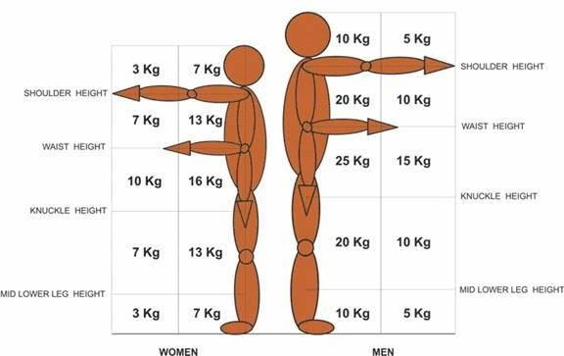

# Manual Handling Techniques Guide

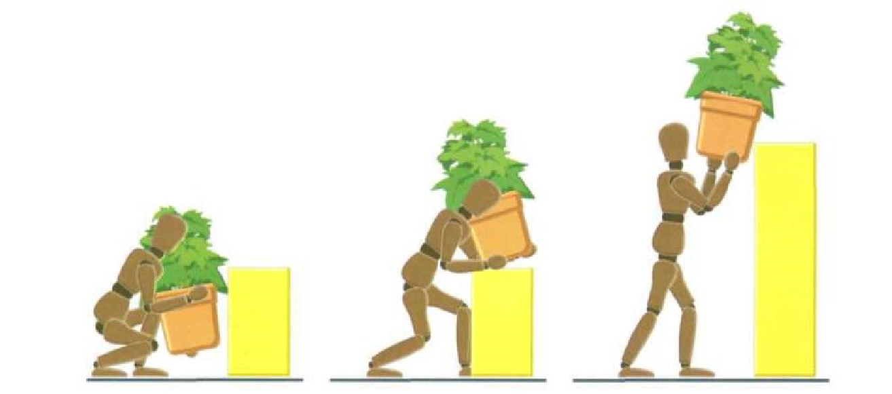

The main elements of good lifting technique

1. Check that you are wearing suitable clothing and assess the load, place heaviest side to the body.
2. Place your feet apart and bend the knees
3. Place a firm grip, close to the body and slightly bending the back, hips and knees
4. Lift gently to the knee and then to waist level.
5. Check visibility and move forward keeping the load close to the waist, turn by moving your feet and keep your head upright, do not look down at the load
6. Set the load down at waist height or knee level and gently lower to the floor.

# Manual Handling Assessment Checklist

This form need only be completed for tasks that have been identified by the filtering process as presenting a significant risk and cannot be eliminated.

|  |
| --- |
| **Task covered by this**  **assessment:** |
| **Categories of**  **personnel involved:** |

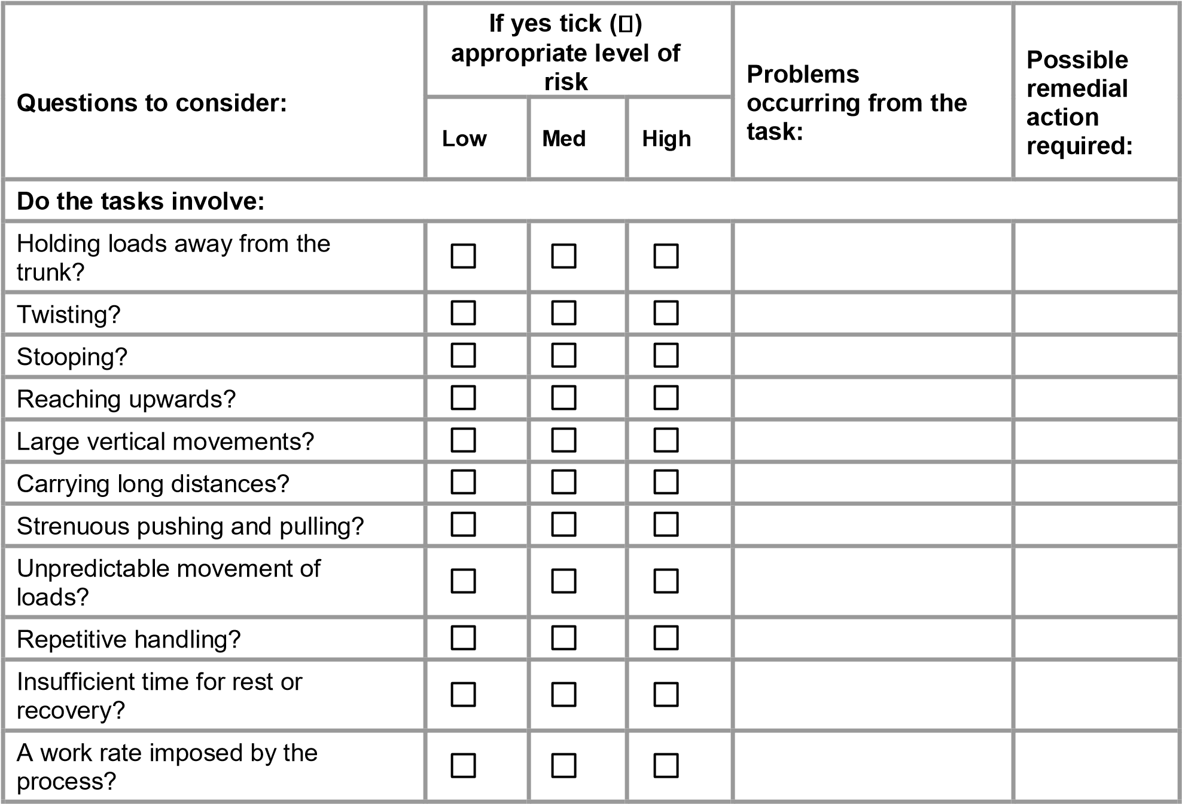

|  |  |  |  |  |  |  |  |  |  |  |  |
| --- | --- | --- | --- | --- | --- | --- | --- | --- | --- | --- | --- |
| **Are the loads:** | | | | | | | | | | | |
| Heavy? |  |  |  |  |  |  |  |  |  |  |  |
|  |  |  |
| Bulky/unwieldy? |  |  |  |  |  |  |  |  |  |  |  |
|  |  |  |
| Difficult to grip? |  |  |  |  |  |  |  |  |  |  |  |
|  |  |  |
| Unstable/unpredictable? |  |  |  |  |  |  |  |  |  |  |  |
|  |  |  |
| Intrinsically harmful? |  |  |  |  |  |  |  |  |  |  |  |
|  |  |  |

|  |  |  |  |  |  |  |  |  |  |  |  |
| --- | --- | --- | --- | --- | --- | --- | --- | --- | --- | --- | --- |
| **Does the working environment have:** | | | | | | | | | | | |
| Constraints on posture? |  |  |  |  |  |  |  |  |  |  |  |
|  |  |  |
| Poor floors? |  |  |  |  |  |  |  |  |  |  |  |
|  |  |  |
| Variations in levels? |  |  |  |  |  |  |  |  |  |  |  |
|  |  |  |
| Hot/cold humid conditions? |  |  |  |  |  |  |  |  |  |  |  |
|  |  |  |
| Strong air movements? |  |  |  |  |  |  |  |  |  |  |  |
|  |  |  |
| Poor lighting? |  |  |  |  |  |  |  |  |  |  |  |
|  |  |  |

|  |  |  |  |  |  |  |  |  |  |  |  |
| --- | --- | --- | --- | --- | --- | --- | --- | --- | --- | --- | --- |
| **Individual capability:** | | | | | | | | | | | |
| **Does the job:** | | | | | | | | | | | |
| Require unusual capability? |  |  |  |  |  |  |  |  |  |  |  |
|  |  |  |
| Present a hazard to those with a health problem? |  | | |  | | |  | | |  |  |
| Present an additional hazard to those who are pregnant? |  | | |  | | |  | | |  |  |
| Require special information and training? |  | | |  | | |  | | |  |  |
| **Other factors:** | | | | | | | | | | | |
| Is movement or posture hindered by clothing or PPE? |  | | |  | | |  | | |  |  |

**Signed (Assessor):**

**Date:**